MACHINE LEARNING MODEL DEVELOPMENT
AND EVALUATION
Titanic Passenger Survival Prediction
Using Logistic Regression and Decision Tree Classification
Week 4 Internship Task — Machine Learning Model Development and Evaluation
Dataset: Titanic_Cleaned.csv (891 passenger records)
Tools: Python, Pandas, NumPy, Scikit-learn, Matplotlib, Seaborn
Prepared as part of the Data Science / Machine Learning Internship Program

1 Abstract
2 Introduction
3 Project Objective
4 Dataset Description
4.1 Features Used

5 Data Preparation
5.1 Feature Selection
5.2 Encoding Categorical Variables
5.3 Train/Test Split
5.4 Feature Scaling

6 Feature Engineering
7 Model Selection
7.1 Logistic Regression (Primary Model)
7.2 Decision Tree (Comparison Model)

8 Model Training
8.1 Logistic Regression
8.2 Decision Tree

9 Model Evaluation
9.1 Evaluation Metrics — Definitions
9.2 Logistic Regression Results
9.3 Classification Report — Logistic Regression
9.4 Decision Tree Results

10 Confusion Matrix — Visualization 1
11 ROC Curve — Visualization 2
12 Model Comparison — Visualization 3
13 Overfitting and Underfitting
13.1 Overfitting
13.2 Underfitting

14 Critical Error Analysis
15 Model Improvement
15.1 Feature Engineering
15.2 Hyperparameter Tuning
15.3 Cross-Validation
15.4 Additional Algorithms

16 Conclusion
17 Work Plan Summary

1. Abstract
This report documents the development, training, and evaluation of a machine learning classification model built to predict passenger survival on the Titanic. Building on the data cleaning (Week 1), exploratory visualization (Week 2), and statistical testing (Week 3) performed in earlier stages of the internship, this Week 4 task applies supervised machine learning to the same cleaned dataset. Two classification algorithms — Logistic Regression and a Decision Tree — were trained on 712 passenger records and evaluated on 179 held-out records. The Logistic Regression model achieved an accuracy of 80.4% and an ROC-AUC of 0.843, while the Decision Tree achieved an accuracy of 78.8%. The report presents the full pipeline, evaluation metrics, supporting visualizations, an analysis of potential sources of error, and recommendations for future improvement.

2. Introduction
Machine learning (ML) is a branch of artificial intelligence in which algorithms learn patterns directly from data rather than following explicitly programmed rules. In a supervised classification task, the algorithm is given a set of labeled examples — input features paired with a known outcome — and learns a function that maps new, unseen inputs to the correct outcome category.
This project frames Titanic survival prediction as a binary classification problem, where the target variable Survived takes one of two values:
- 0 — Passenger did not survive
- 1 — Passenger survived
The objective is to learn the relationship between a passenger's characteristics (class, sex, age, fare, and family composition) and their survival outcome, and to evaluate how reliably that relationship generalizes to passengers the model has not seen during training.

3. Project Objective
Research question: Can we predict whether a Titanic passenger survived based on characteristics such as passenger class, gender, age, fare, and family information?
The specific goals of this task were to:
- Prepare the cleaned Titanic dataset for machine learning by selecting and encoding relevant features.
- Train and evaluate a Logistic Regression model as the primary, interpretable baseline classifier.
- Train a Decision Tree classifier as a comparison model.
- Evaluate both models using accuracy, precision, recall, F1-score, and ROC-AUC.
- Visualize model performance using a confusion matrix, ROC curve, and a comparative bar chart.
- Critically discuss sources of error, overfitting/underfitting, and directions for improvement.

4. Dataset Description
The model was trained on the cleaned version of the classic Titanic dataset produced during Week 1 of the internship (Titanic_Cleaned.csv).
Property | Value
Total observations | 891 passengers
Total columns | 11
Missing values after cleaning | 0 (dataset fully cleaned in Week 1)
Target variable | Survived (binary: 0 = No, 1 = Yes)
Class distribution | 549 did not survive (61.6%) / 342 survived (38.4%)

The target class distribution is moderately imbalanced (roughly 62% negative vs. 38% positive), which was accounted for using stratified sampling during the train/test split (see Section 6.4) and is discussed further in the Error Analysis (Section 11).

4.1 Features Used
Of the 11 available columns, the following seven predictive features were selected for modeling. Identifier and free-text fields (PassengerId, Name, Ticket, Cabin) were excluded as they carry no direct predictive signal for a beginner classification model.
Feature | Description | Type
Pclass | Ticket / passenger class (1st, 2nd, 3rd) | Categorical (ordinal)
Sex | Passenger gender | Categorical
Age | Passenger age in years | Numerical
SibSp | Number of siblings/spouses aboard | Numerical
Parch | Number of parents/children aboard | Numerical
Fare | Ticket fare paid | Numerical
Embarked | Port of embarkation (S, C, Q) | Categorical

5. Data Preparation
Because the dataset had already been cleaned in Week 1 (no missing values remained, confirmed via df.isnull().sum()), Week 4 preparation focused on getting the data into a numeric, model-ready format.

5.1 Feature Selection
The seven features listed in Section 4.1 were selected as the independent variables (X), with Survived set as the dependent target variable (y):
X = df[["Pclass", "Sex", "Age", "SibSp", "Parch", "Fare", "Embarked"]]
y = df["Survived"]

5.2 Encoding Categorical Variables
Machine learning algorithms require numeric input, so the categorical columns Sex and Embarked were converted to numeric dummy variables using one-hot encoding, with the first category dropped in each case to avoid redundancy (the dummy variable trap):
X = pd.get_dummies(X, columns=["Sex", "Embarked"], drop_first=True)
This produced the following numerical feature set: Pclass, Age, SibSp, Parch, Fare, Sex_male, Embarked_Q, and Embarked_S.

5.3 Train/Test Split
The data was split into an 80% training set and a 20% testing set, stratified on the target variable to preserve the survival class ratio in both partitions:
X_train, X_test, y_train, y_test = train_test_split(
X, y, test_size=0.20, random_state=42, stratify=y
)
Partition | Rows | Columns
Training set | 712 | 8
Testing set | 179 | 8

Splitting the data ensures the model is evaluated on passengers it has never seen, giving an honest estimate of how it would perform on new data rather than simply memorizing the training set.

5.4 Feature Scaling
Logistic Regression is sensitive to the scale of input features, since its coefficients are optimized using gradient-based methods that converge faster and more reliably when features share a comparable range. StandardScaler was therefore applied to standardize all features to zero mean and unit variance:
scaler = StandardScaler()
X_train_scaled = scaler.fit_transform(X_train)
X_test_scaled = scaler.transform(X_test)
Critically, the scaler was fit only on the training data (fit_transform) and then applied to the test data using transform only. Fitting the scaler on the test set would leak information about the test distribution into the training process, artificially inflating performance — a common and important pitfall to avoid.
The Decision Tree model does not require feature scaling, since tree-based splits are based on threshold comparisons that are invariant to monotonic transformations of a feature's scale. It was therefore trained on the unscaled X_train / X_test data.

6. Feature Engineering
For this iteration of the model, seven raw features plus their one-hot encoded categorical variants were used directly, keeping the pipeline simple and interpretable for a baseline model. No derived features were engineered in this version, but Section 13 discusses specific engineered features (e.g., FamilySize, IsAlone, Title) that were identified as promising directions for a future iteration.

7. Model Selection

7.1 Logistic Regression (Primary Model)
Logistic Regression was selected as the primary model because it is:
- Simple and fast to train, making it an appropriate baseline for a first classification project.
- Highly interpretable — its coefficients indicate the direction and relative strength of each feature's association with survival.
- Well suited to binary classification problems, since it directly models the probability of class membership using the logistic (sigmoid) function.

7.2 Decision Tree (Comparison Model)
A Decision Tree classifier (max_depth = 4) was trained as a second, comparison model. Decision Trees:
- Capture non-linear relationships and feature interactions that a linear model like Logistic Regression cannot.
- Do not require feature scaling.
- Are also highly interpretable, since the learned splits can be visualized as a flowchart of decision rules.
The maximum depth was deliberately restricted to 4 to control model complexity and reduce the risk of overfitting on a relatively small dataset (see Section 12).

8. Model Training

8.1 Logistic Regression
model = LogisticRegression(random_state=42)
model.fit(X_train_scaled, y_train)
y_pred = model.predict(X_test_scaled)

8.2 Decision Tree
tree_model = DecisionTreeClassifier(max_depth=4, random_state=42)
tree_model.fit(X_train, y_train)
tree_pred = tree_model.predict(X_test)

9. Model Evaluation
Both models were evaluated on the same 179-row held-out test set using four standard classification metrics, plus ROC-AUC for the Logistic Regression model.

9.1 Evaluation Metrics — Definitions
- Accuracy: the proportion of all predictions that were correct.
- Precision: of all passengers predicted to survive, the proportion that actually survived.
- Recall (Sensitivity): of all passengers who actually survived, the proportion the model correctly identified.
- F1 Score: the harmonic mean of precision and recall, balancing both concerns into a single number.
- ROC-AUC: the area under the Receiver Operating Characteristic curve, summarizing how well the model separates the two classes across all possible decision thresholds.

9.2 Logistic Regression Results
Metric | Score
Accuracy | 0.8045 (80.4%)
Precision | 0.7931 (79.3%)
Recall | 0.6667 (66.7%)
F1 Score | 0.7244 (72.4%)
ROC-AUC | 0.8433

9.3 Classification Report — Logistic Regression
precision recall f1-score support

0 0.81 0.89 0.85 110
1 0.79 0.67 0.72 69

accuracy 0.80 179
macro avg 0.80 0.78 0.79 179
weighted avg 0.80 0.80 0.80 179

The model performs noticeably better on class 0 (did not survive) than on class 1 (survived): recall for survivors is only 67%, meaning roughly a third of passengers who actually survived were misclassified as non-survivors. This asymmetry is discussed further in Section 11.

9.4 Decision Tree Results
Metric | Score
Accuracy | 0.7877 (78.8%)
Precision | 0.8444 (84.4%)
Recall | 0.5507 (55.1%)
F1 Score | 0.6667 (66.7%)

10. Confusion Matrix — Visualization 1
The confusion matrix summarizes the Logistic Regression model's predictions on the 179 test-set passengers, broken down into the four possible outcomes.
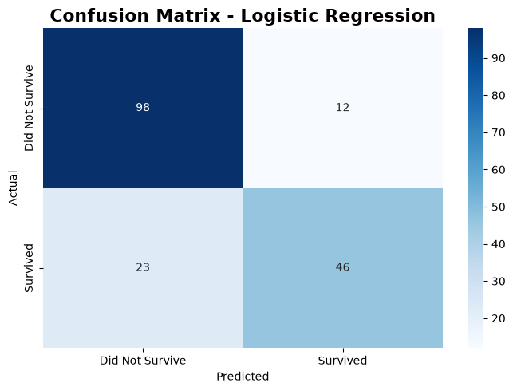
Figure 1. Confusion matrix for the Logistic Regression model on the test set.
Outcome | Meaning | Interpretation for this project
True Negative (TN) | Actual: did not survive; Predicted: did not survive | Correctly identified non-survivor
True Positive (TP) | Actual: survived; Predicted: survived | Correctly identified survivor
False Positive (FP) | Actual: did not survive; Predicted: survived | Model wrongly predicted survival
False Negative (FN) | Actual: survived; Predicted: did not survive | Model missed an actual survivor

The matrix visually confirms the pattern seen in the classification report: the model is more accurate at identifying non-survivors than survivors, meaning false negatives (missed survivors) are more common than false positives in this model.

11. ROC Curve — Visualization 2
The ROC (Receiver Operating Characteristic) curve plots the True Positive Rate against the False Positive Rate across every possible classification threshold, showing how the model's sensitivity and specificity trade off as the decision threshold changes.
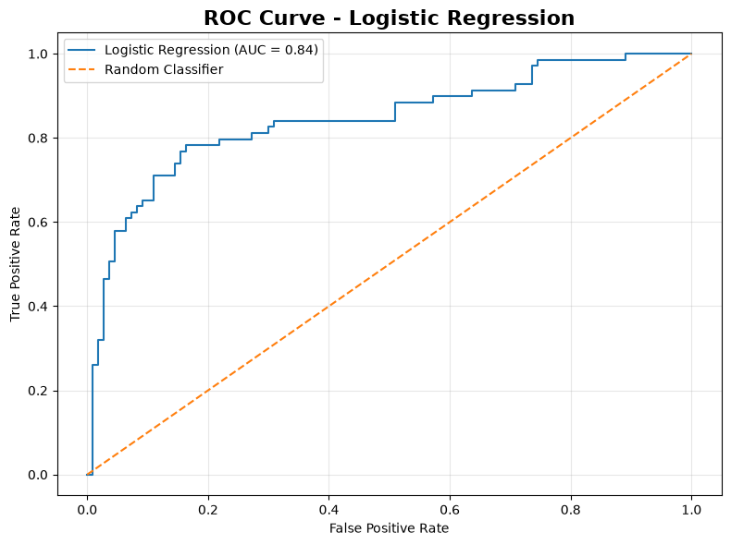
Figure 2. ROC curve for the Logistic Regression model (AUC = 0.84).
The Area Under the Curve (AUC) summarizes this trade-off in a single number between 0 and 1:
AUC Range | Interpretation
0.50 | No better than random guessing
0.60 – 0.70 | Weak discrimination
0.70 – 0.80 | Acceptable discrimination
0.80 – 0.90 | Good discrimination
0.90+ | Excellent discrimination

With an AUC of 0.843, the Logistic Regression model falls in the “Good” range, indicating it separates survivors from non-survivors substantially better than chance, even though its recall on the positive class (survivors) is more modest at the default 0.5 threshold. This gap suggests that adjusting the classification threshold could trade some precision for improved recall if identifying survivors is the priority.

12. Model Comparison — Visualization 3
The table and chart below compare Logistic Regression and the Decision Tree across all four shared evaluation metrics.
Model | Accuracy | Precision | Recall | F1 Score
Logistic Regression | 0.8045 | 0.7931 | 0.6667 | 0.7244
Decision Tree | 0.7877 | 0.8444 | 0.5507 | 0.6667

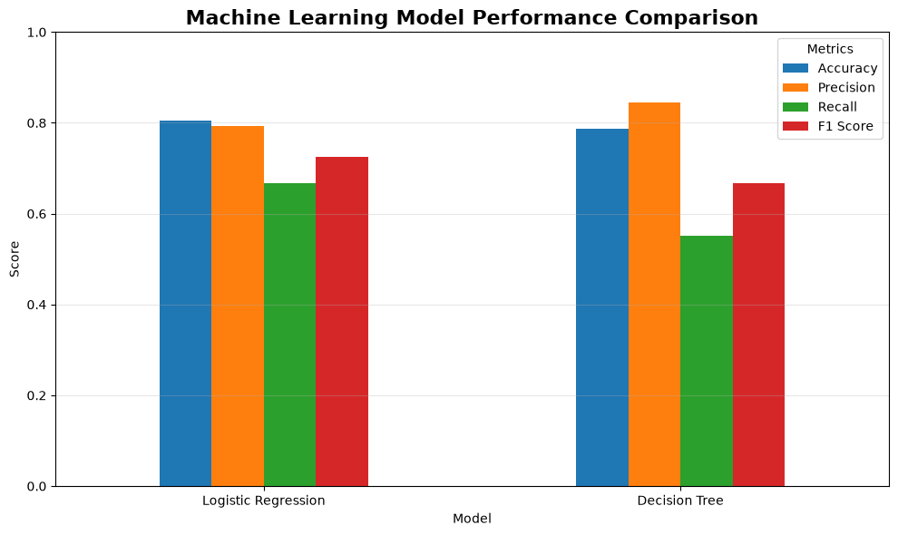
Figure 3. Performance comparison between Logistic Regression and the Decision Tree classifier.
Logistic Regression achieved the higher overall accuracy, recall, and F1 score, while the Decision Tree achieved higher precision. In practical terms, the Decision Tree is more conservative — when it predicts survival, it is right more often (84.4% precision) — but it misses a larger share of actual survivors (only 55.1% recall) than Logistic Regression does (66.7% recall). Given that both accuracy and F1 favor Logistic Regression, it is considered the stronger overall model for this dataset, though the appropriate choice ultimately depends on whether false positives or false negatives are more costly in the intended application.

13. Overfitting and Underfitting

13.1 Overfitting
Overfitting occurs when a model learns the training data too closely — including its noise and idiosyncrasies — resulting in strong training performance but weak generalization to unseen data. Decision Trees are particularly prone to overfitting because, left unconstrained, they can grow branches deep enough to perfectly memorize the training set.
This risk was mitigated by explicitly restricting the tree with max_depth=4, which limits how many sequential splits the tree can make and forces it to generalize using broader, more robust patterns rather than memorizing individual training examples. An unconstrained tree (max_depth=None) could potentially reach 100% training accuracy while performing considerably worse on the test set — a clear symptom of overfitting.

13.2 Underfitting
Underfitting occurs when a model is too simple to capture the real structure in the data, resulting in poor performance on both the training and test sets. Logistic Regression's linear decision boundary carries some risk of underfitting if the true relationship between features and survival is highly non-linear. The moderate-to-good performance observed (80.4% accuracy, 0.843 AUC) suggests the model is capturing a meaningful portion of the underlying signal without being obviously underfit, though the gap in recall for the survivor class indicates there is still room for the model to better capture that group's patterns.

14. Critical Error Analysis
Several factors likely contribute to the errors observed in both models, particularly the shortfall in recall for the “survived” class:
- Missing information: even after cleaning, some passenger attributes (e.g., precise cabin location, exact time and location of death or rescue) were unavailable or approximated, limiting how precisely survival could be modeled.
- Feature limitations: the selected features do not capture every factor that plausibly influenced survival, such as a passenger's physical proximity to lifeboats, swimming ability, or specific crew decisions during the evacuation.
- Historical dataset: the data reflects a single historical maritime disaster with its own unique social and procedural context (e.g., "women and children first" evacuation norms), so patterns learned here may not generalize to other emergency scenarios.
- Class imbalance: with 61.6% non-survivors versus 38.4% survivors, the model has more examples to learn non-survival patterns from, which likely contributes to its stronger performance on class 0 and weaker recall on class 1.
- Model simplicity: Logistic Regression assumes an approximately linear relationship (in log-odds) between features and outcome, which may not fully capture more complex interactions, such as how class and gender jointly affected survival odds.
- Limited dataset size: with only 891 total passengers (712 for training), both models were trained on a relatively small sample, which increases the influence of individual data points and the variability of performance estimates.
False negatives (predicting a survivor as a non-survivor) were more common than false positives in the Logistic Regression model, as shown in the confusion matrix in Section 10. In a real-world safety or resource-allocation context, this pattern would be worth addressing directly, for example by adjusting the classification threshold to favor recall over precision.

15. Model Improvement
Several concrete directions could improve model performance in a future iteration of this project:

15.1 Feature Engineering
Additional derived features could capture patterns not present in the raw columns, for example:
df["FamilySize"] = df["SibSp"] + df["Parch"] + 1
df["IsAlone"] = (df["FamilySize"] == 1).astype(int)
- FamilySize — total family members aboard, which may relate to how quickly a group could reach a lifeboat.
- IsAlone — whether a passenger was traveling without family.
- Title — a passenger's social title extracted from their name (e.g., Mr., Mrs., Master), which can act as a proxy for age and social status.
- Mother / Child indicators — flags identifying passengers likely to fall under evacuation priority norms.

15.2 Hyperparameter Tuning
Systematically searching over model hyperparameters using GridSearchCV could identify better-performing configurations (e.g., regularization strength for Logistic Regression, or max_depth and min_samples_leaf for the Decision Tree) than the defaults used here.

15.3 Cross-Validation
Relying on a single train/test split, as done in this report, produces a performance estimate that can vary depending on which rows happen to fall into the test set. Using cross_val_score() with k-fold cross-validation would provide a more robust, averaged estimate of model performance and reduce the influence of any one particular split.

15.4 Additional Algorithms
Future iterations could compare against additional algorithms such as Random Forest, Gradient Boosting, K-Nearest Neighbors, or Support Vector Machines, which may capture more complex feature interactions than either model used here. This was intentionally scoped out of the current task to keep Week 4 focused on foundational modeling concepts.

16. Conclusion
This task provided hands-on experience with the full supervised machine learning pipeline: preparing data for modeling, encoding categorical variables, splitting and scaling data correctly, training two different types of classifiers, and evaluating them using multiple complementary metrics and visualizations.
Between the two models tested, Logistic Regression outperformed the Decision Tree on accuracy (80.4% vs. 78.8%), recall (66.7% vs. 55.1%), and F1 score (72.4% vs. 66.7%), while the Decision Tree achieved higher precision (84.4% vs. 79.3%). Combined with a strong ROC-AUC of 0.843, Logistic Regression is judged the stronger baseline model overall for this dataset, offering a good balance of interpretability and predictive performance.
At the same time, both models show a consistent weakness in recall for the survivor class, reflecting real limitations in the available features, the dataset's size, and its class imbalance. These findings motivate the specific next steps outlined in Section 15 — particularly feature engineering and cross-validation — as the most promising avenues for improving the model in a future iteration.

17. Work Plan Summary
The task was completed within the internship's specified 30–35 hour timeframe, distributed across the following activities:
Activity | Hours
Dataset preparation | 3
Feature engineering / selection | 4
ML concepts and research | 3
Logistic Regression development | 4
Decision Tree development | 4
Model evaluation | 4
Visualizations | 3
Error analysis | 2
Report preparation | 5
Total | 32

